**Java Queue Interface**

The Queue interface of the Java collections framework provides the functionality of the queue data structure. It extends the Collection interface.

## Classes that Implement Queue

Since Queue is an interface, we cannot provide the direct implementation of it.

In order to use the functionalities of Queue, we need to use classes that implement it:

* ArrayDeque
* LinkedList
* PriorityQueue

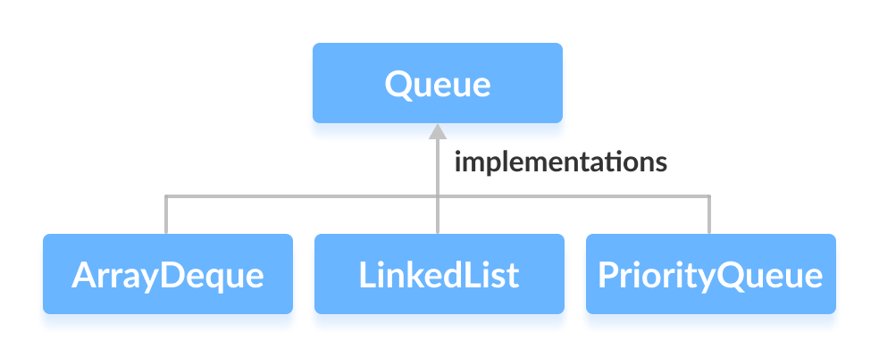

## Working of Queue Data Structure

In queues, elements are stored and accessed in **First In, First Out** manner. That is, elements are **added from the behind** and **removed from the front**.

## How to use Queue?

In Java, we must import java.util.Queue package in order to use Queue.

// LinkedList implementation of Queue

Queue<String> animal1 = new LinkedList<>();

// Array implementation of Queue

Queue<String> animal2 = new ArrayDeque<>();

// Priority Queue implementation of Queue

Queue<String> animal 3 = new PriorityQueue<>();

Here, we have created objects animal1, animal2 and animal3 of classes LinkedList, ArrayDeque and PriorityQueue respectively. These objects can use the functionalities of the Queue interface.

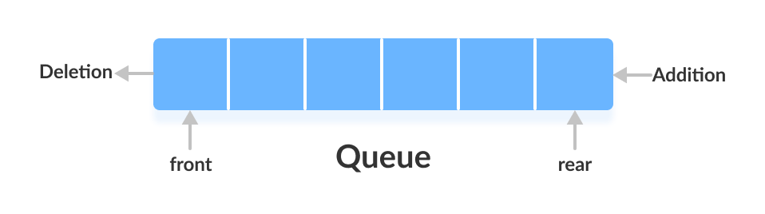

## Methods of Queue

The Queue interface includes all the methods of the Collection interface. It is because Collection is the superinterface of Queue.

Some of the commonly used methods of the Queue interface are:

* **add()** - Inserts the specified element into the queue. If the task is successful, add() returns true, if not it throws an exception.
* **offer()** - Inserts the specified element into the queue. If the task is successful, offer() returns true, if not it returns false.
* **element()** - Returns the head(top) of the queue. Throws an exception if the queue is empty.
* **peek()** - Returns the head of the queue. Returns null if the queue is empty.
* **remove()** - Returns and removes the head of the queue. Throws an exception if the queue is empty.
* **poll()** - Returns and removes the head of the queue. Returns null if the queue is empty.

## Implementation of the Queue Interface

**1. Implementing the LinkedList Class**

import java.util.Queue;

import java.util.LinkedList;

class Main {

public static void main(String[] args) {

// Creating Queue using the LinkedList class

Queue<Integer> numbers = new LinkedList<>();

// offer elements to the Queue

numbers.offer(1);

numbers.offer(2);

numbers.offer(3);

System.out.println("Queue: " + numbers);

// Access elements of the Queue

int accessedNumber = numbers.peek();

System.out.println("Accessed Element: " + accessedNumber);

// Remove elements from the Queue

int removedNumber = numbers.poll();

System.out.println("Removed Element: " + removedNumber);

System.out.println("Updated Queue: " + numbers);

}

}

**Output**

Queue: [1, 2, 3]

Accessed Element: 1

Removed Element: 1

Updated Queue: [2, 3]

To learn more about LinkedList, visit Java LinkedList.

**2. Implementing the PriorityQueue Class**

import java.util.Queue;

import java.util.PriorityQueue;

class Main {

public static void main(String[] args) {

// Creating Queue using the PriorityQueue class

Queue<Integer> numbers = new PriorityQueue<>();

// offer elements to the Queue

numbers.offer(5);

numbers.offer(1);

numbers.offer(2);

System.out.println("Queue: " + numbers);

// Access elements of the Queue

int accessedNumber = numbers.peek();

System.out.println("Accessed Element: " + accessedNumber);

// Remove elements from the Queue

int removedNumber = numbers.poll();

System.out.println("Removed Element: " + removedNumber);

System.out.println("Updated Queue: " + numbers);

}

}

**Output**

Queue: [1, 5, 2]

Accessed Element: 1

Removed Element: 1

Updated Queue: [2, 5]